**Project Design Phase-II**

**Technology Stack (Architecture & Stack)**

|  |  |
| --- | --- |
| Date | 27 June 2025 |
| Team ID | LTVIP2025TMID44403 |
| Project Name | Pattern Sense:Classifying Fabric Ptterns using Deep Learning |
| Maximum Marks | 4 Marks |

**Technical Architecture:**

The Deliverable shall include the architectural diagram as below **:**

Guidelines:

Include all the processes (As an application logic / Technology Block)

Provide infrastructural demarcation (Local / Cloud)

Indicate external interfaces (third party API’s etc.)

Indicate Data Storage components / services

Indicate interface to machine learning models (if applicable)

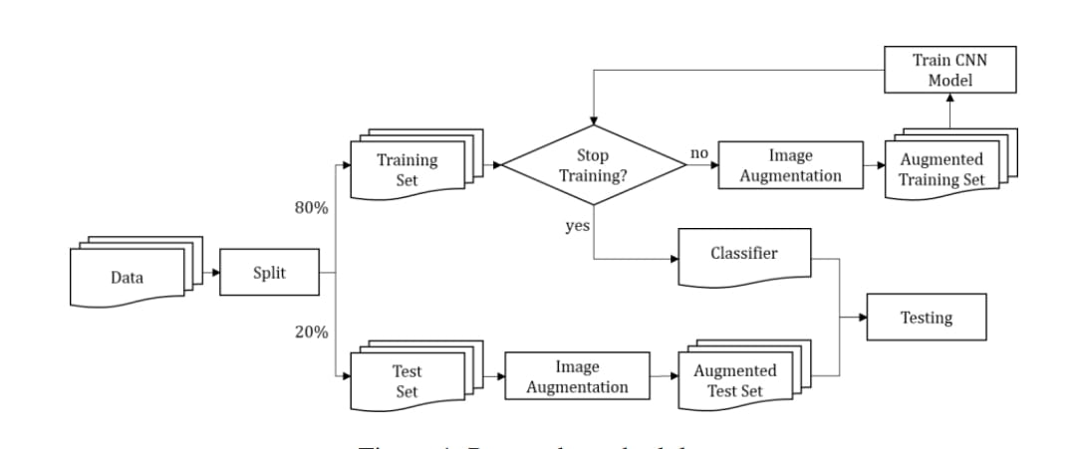

**Technology Stack :**

Frontend : HTML,CSS

Backend : Python , OpenCV (for image processing and enhancement)

Convolutional Neural Networks (CNNs)

TensorFlow or Pytorch (for deep learning model development)

Scikit-learn (for classical ML comparisions or model evaluation)

Matplotlib/Seaborn (for visualization)

Database : MYSQL (for storing user data,history,reports)

Deployment : Render/Vercel/Heroku/AWS(for hosting web app)